Procedure for field closures and Signing up for Town of Colchester Field Status updates

On weekdays, the Town will make the announcement of field closure by 3 pm. If the town says that a field is closed – no one can use it that day/night. If the town leaves a field ‘open’ for use on a given day, but weather or field conditions change after 3 pm, the coaches and coordinators will make the call. On weekends – it is up to coaches and coordinators to make the call on field conditions.
The Colchester Baseball and Softball league website has a tab for the Field listings that can be updated to reflect field closures – but this is done manually. If the town announces a field closure, the fastest way to be aware of this is to subscribe directly to the town website so when they issue the message, you receive it directly. Directions for doing that are below.
Always take your coach’s messages as being the most accurate source of status information – sometimes the website can be delayed in being updated – so check for emails or messages from your coach in addition to checking the website.

To get the messages directly from the town:
- Go to the town webpage at: https://www.colchesterct.gov/
- Scroll to the bottom of the page and click on the ‘Subscribe’ link

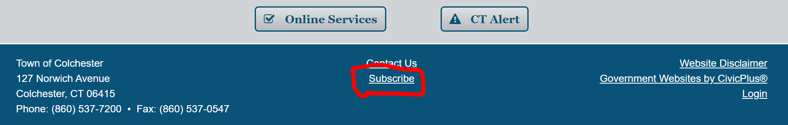

- Scroll down to where you can enter and confirm your email address – where you will receive the notification emails

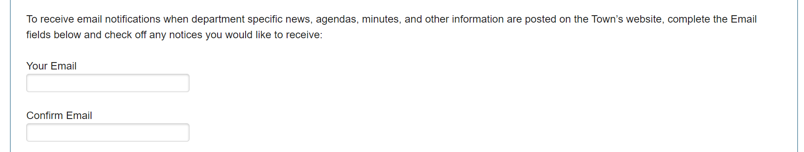

- Keep scrolling and be sure to click the check box next to the Public Works / Field Status option (in addition to anything else you want to be notified about)
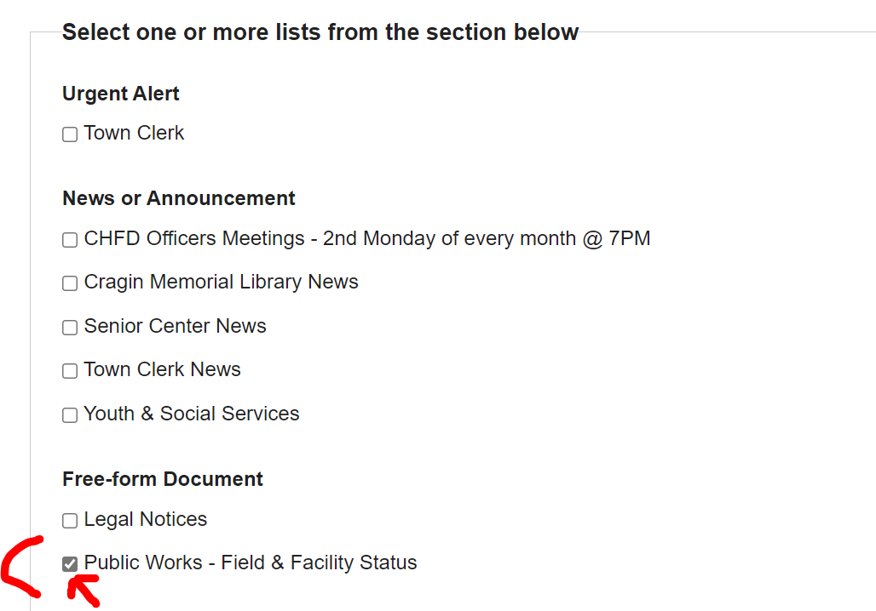

- Make the ‘I am not a robot’ thing happy and then click ‘Subscribe Me’
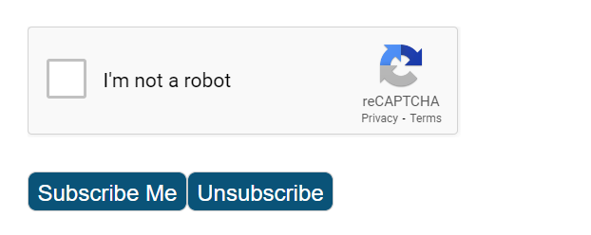

- Remember that there is only a notification if a field or field(s) are CLOSED. If there is no email notification before 3:30 pm, consider the fields open according to the town and watch for emails from your coach with any other details or changes.

